**DBS Lab 5**

**Data Defination language (DDL)**

1. **CREATE TABLE:**

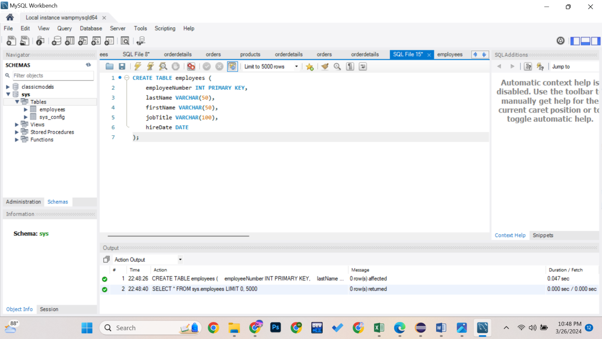

1. **ALTER TABLE:**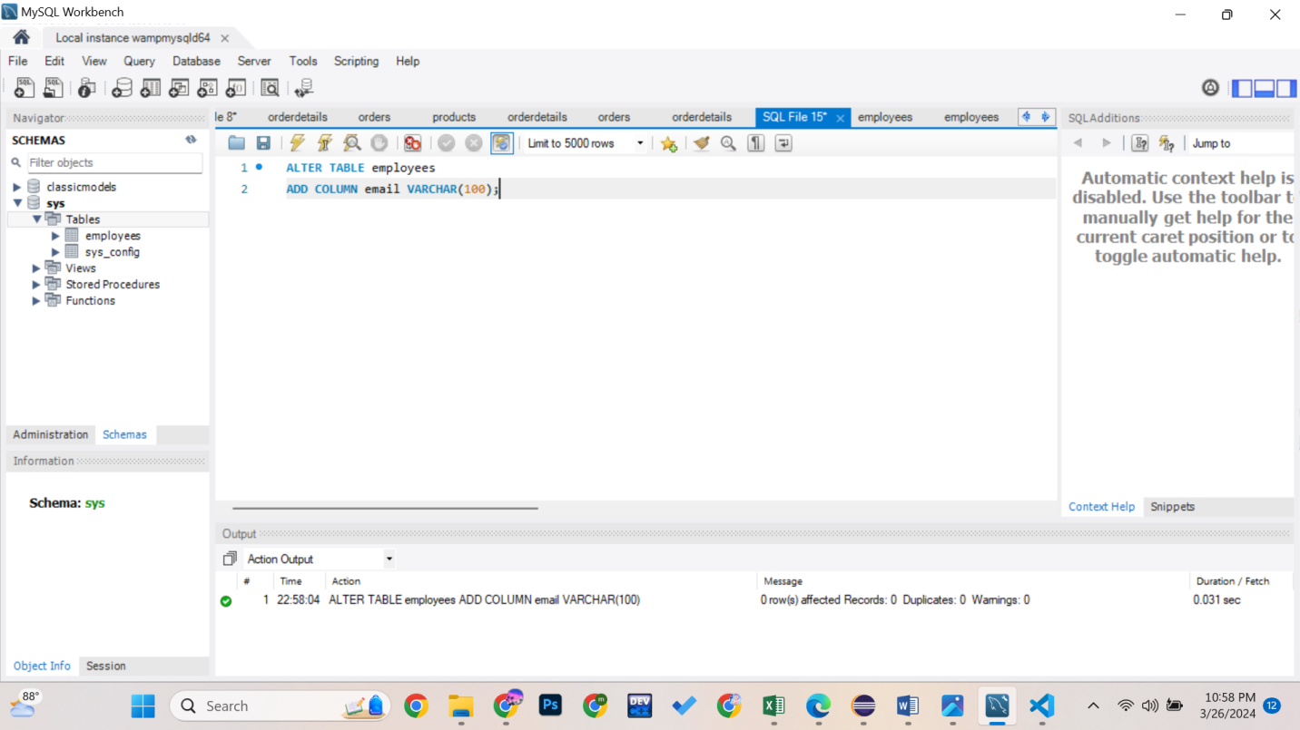
2. **RENAME TABLE:**

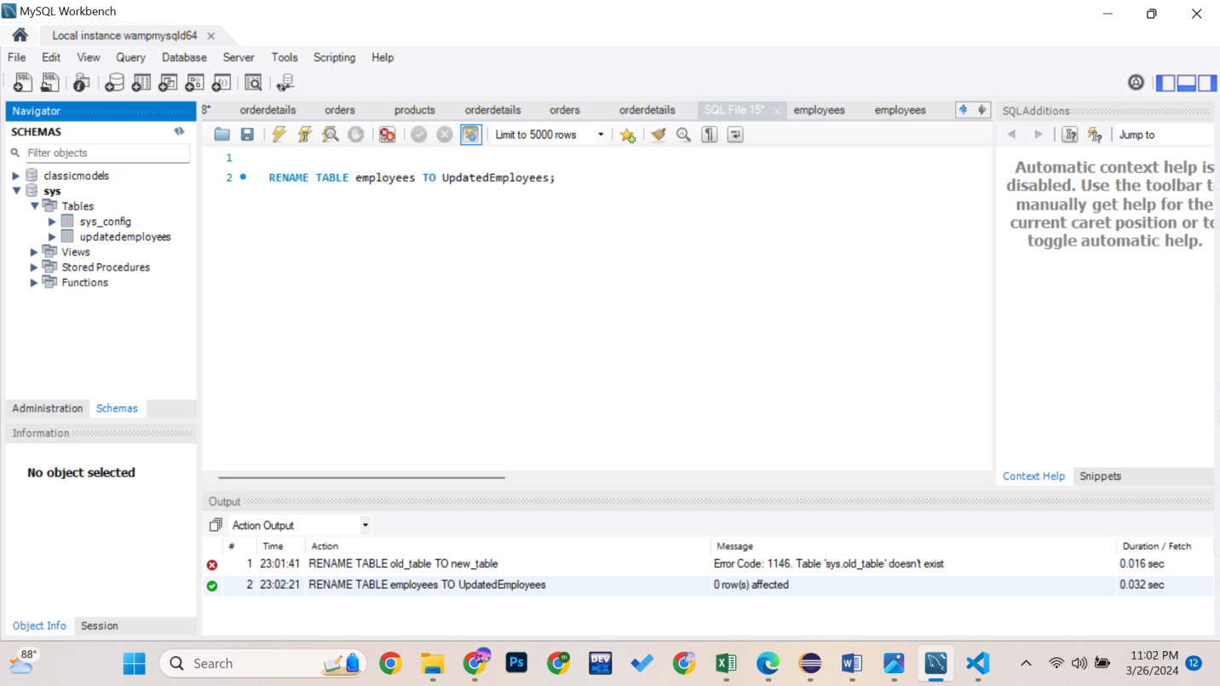

1. **DROP TABLE:**

